

SOFTWARE ENGINEERING
REPORT

SID: 2118074

MOD003263

BSc Artificial Intelligence
Anglia Ruskin University
Computing & Technology Department
Submission Date – 11/12/2023
TABLE OF CONTENTS

1. INTRODUCTION 1
2. PROBLEM DEFINITION DOCUMENT 2
Case Study 2
Aim of the project 2
Plan of the project 3
System Requirements 5
Resources Used 5
User Stories 6
3. SOFTWARE DESIGN 8
3.1. WIREFRAME 8
3.2. DATABASE DESIGN 10
3.3. UML DESIGN DIAGRAMS 14
3.3.1. Use Case Diagram 14
3.3.2. Class Diagram 15
3.3.3. Sequence Diagram 16
4. SOFTWARE DEVELOPMENT DOCUMENTATION 24
4.1. User story 1. 24
4.2. User story 2. 24
5. TESTING 24
6. PLAN OF THE SOFTWARE MAINTENANCE 26
7. CONCLUSIONS 30
8. REFERENCES 31

INTRODUCTION

This report demonstrates the development of Vendor Application Inventory software for Citisoft during the academic year 2023-24. This report shows how well the author understands the concepts and the methods of software engineering. It details the steps involved in developing and producing the suggested software. A group of five people participated in the creative process from the outset, and each person worked constructively and productively.

The report describes how the author and team came up with the software designs and concepts, how the team overcame the difficulties encountered during the development stages, a demonstration of the piece of software which the author was working on, demonstration of software testing, and ultimately the maintenance plan for the developed software.

PROBLEM DEFINITION DOCUMENT

Case Study
Citisoft is a company providing strategic planning and design services for global asset managers. Clients of Citisoft try to develop comprehensive technology and operations infrastructures with Citisoft's guidance (Wall-street and Tech-guide). In order to provide strategic planning and design services for global asset managers, Citisoft's employees need to have a comprehensive understanding of various products and vendors. However, the needed information is spread over different locations and different format types, making the research inefficient and time-consuming. Thereby losing out on time that could have been allocated to different clients, in turn missing out on opportunities for new clients and eventually falling short on potential revenue (Software Engineering Live Brief, September 2023).

Aim of the project
This project aims to create a piece of software to be used by Citisoft that tries to tackle the current inefficiencies in how employees at Citisoft have to source information and the potential revenue loss that follows through that. The software allows employees to aggregate and analyse vendors, their products, and the product's capabilities. The software is used to select suitable solutions for clients by looking and searching through the stored products and vendors in the program and having the option to adjust them by adding new ones, editing already existing ones, and additionally removing unnecessary ones. By providing a more efficient and comprehensive way of managing data, the software can improve Citisoft's performance.

Plan of the project
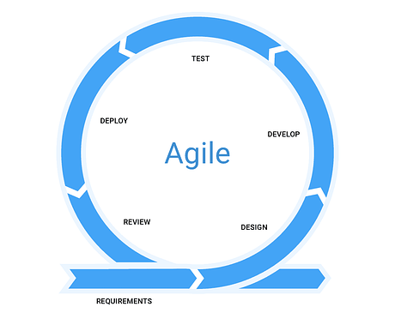
In order to create the program, the agile development cycle will be followed (figure 1). The “agile development cycle” is a way of approaching the development of a software with focus on the people requesting the program (Cockburn, 2001).
Figure 1. Represents the Agile Software Development Cycle.
Firstly, the outlines of the software requirements will be defined and then broken down into user stories. User stories help developer teams to understand what and why users want (Max Rehkopf, nd). This makes them essential to the agile development cycle because a feedback relation with the customer can easily be sustained. The user stories are the cornerstone of the program. Everything around the development is based on them. The following software design will be done with diagrams. The user interface will be created from a wireframe, a visual, un-functional picture representation for the final product (Nick Babich, 2022). The database to store vendors and products will be created from the extended entity relationship diagram, a diagram to design an efficient database structure (John Mylopoulos, 2004).
The program design and structure will be closer defined through the use case diagram showing what the product is supposed to be capable of (What is Use Case Diagram?, visual paradigm), the class diagram, which visualises the program with all its classes, attributes, methods and the relationships among objects. (What is Class Diagram? Visual paradigm), Furthermore, the sequence diagram shows specific processes in the program. (Lucid chart, UML Sequence Diagram Tutorial). In the case of the Citisoft application displaying the user stories
The program's code will then be developed using the Visual Studio development environment in the C# language with the help of a GitHub repository, which will support and be used as a repository for the cooperative work of a group of people. Manuel tests are faster and produce instant results, making them much more flexible than automation tests, which require more planning and investment into development on their own (Akshay Pai, 2023). As a result, multiple people will test the software manually since the program is small in scale. The last step of agile development is the reviewing and maintenance of the program. Through the testing, bugs will already be revealed and partly addressed.
The final step of the agile development cycle is software maintenance, which will be addressed by following Sommerville's (2010) example of software maintenance, dividing it into three sections.

System Requirements
The Software Application requires the following requirements in order to function:
1. A computer running Windows 7 or a later version to prevent incompatibilities.
2. A keyboard to enter login details & to search for the specific application.
3. A mouse to navigate through the GUI (Graphical User Interface).
4. An internet connection to get access to the data within the application and to get update on the latest changes.

Resources Used
The following resources were used to successfully complete this project:
- Lucid Chart
- Google Chrome Version 119.0.6045.160 (64-bit)
- Microsoft Word 365
- Microsoft PowerPoint 365
- Discord 1.0.9024
- Microsoft Visual Studio 17.7.5
- GitHub Version 3.11.0
- Grammarly

User Stories
This are the following User Stories for Vendor Application Inventory for Citisoft:
- As a User, I should be able to register a new account in the system so that I can access into the software whenever I want.
- As a User/ database analyst, I should be able login into the account so that I can browse through the software whenever in want.
- As a database administrator, I want users to have access rights so that what a user can do with the system depends on their access rights.
- As a database administrator, I want to be able to edit the data related to the user so that if login issues occur, I can fix them.
- As a database analyst, I want a user-friendly main menu which GUI is not over complicated, so that I am not confused while using the application.
- As a database analyst, I want to be able search and view the database through the software, so I can identify and select the appropriate technology for the business needs of the client.
- As a database analyst, I want to be able to select categories and filter through the database entries to specify my search as much as possible.
- As a database analyst, I want to be able to select/open links inside the application to have faster access to vendor and product websites.
- As a database analyst, I want to be able to select/open PDFs documents through the software, so I can view the PDFs online.
- As a database analyst, I want a data repository that can store data on vendors and their products so that I have easy access to all the data in one place.
- As a database engineer, I want to be able to edit the database of the vendors and products, so that the database analyst is up to date on current/new vendors and products.
- As a database engineer, I want to be able to delete product/vendor database entries so I can make sure that old entries that are not of any use anymore can be deleted and will not confuse the users.
- As a database engineer, I want to be able to add new data entries to the database so that the database is kept up to date on new information.
- As a database analyst, I want to be able to generate a PDF report that can be downloaded and displays information of products.
- As a database administrator, I want to be able to specify the date which vendors should be reviewed so that information on the vendor is kept up to date.
- As a database analyst, I want to be able to rate and comment on products (and vendors) so other database analysts know which products are good quality (or which vendors are reliable).

SOFTWARE DESIGN

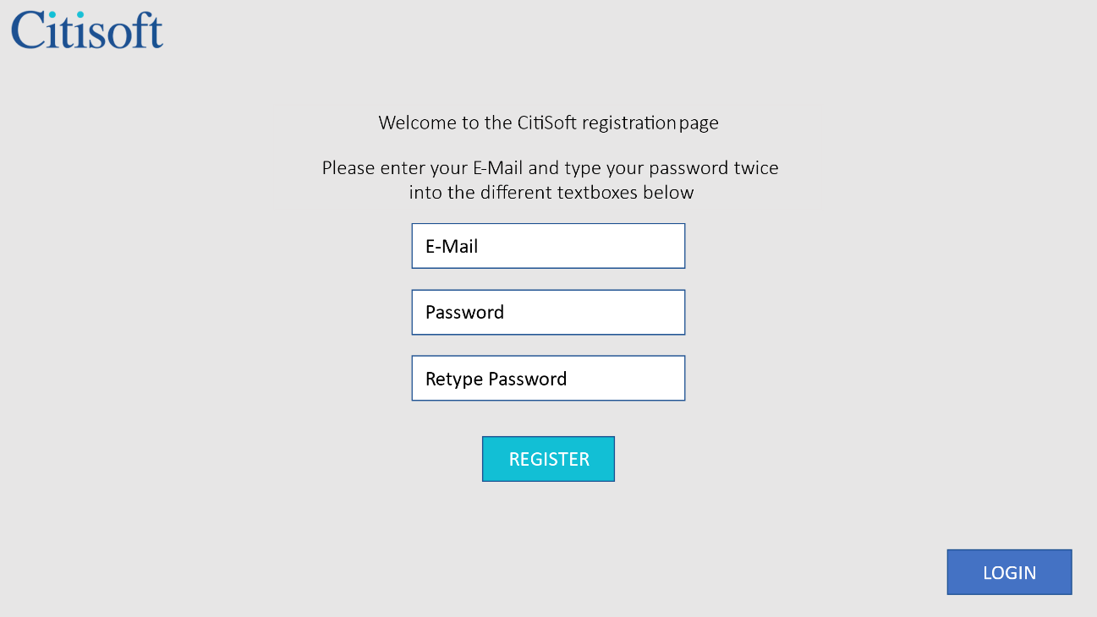
WIREFRAME
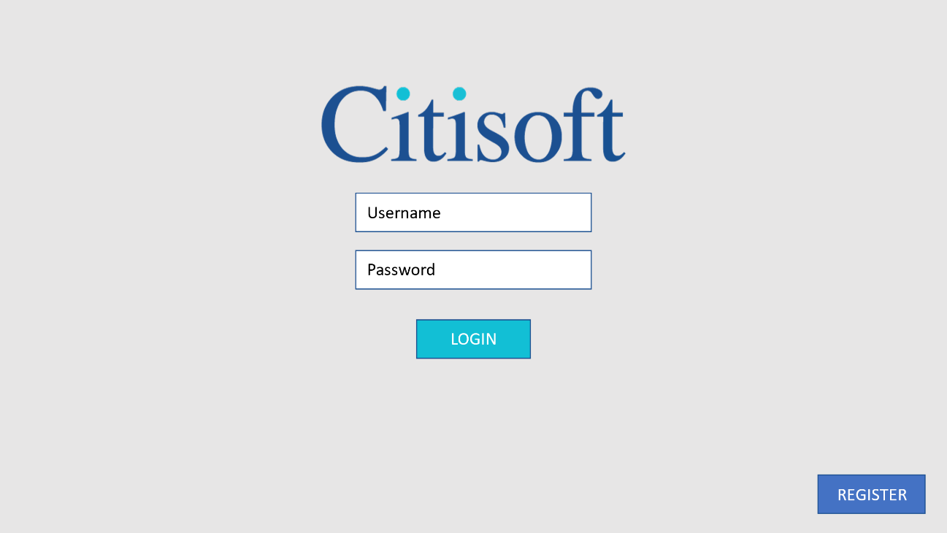
Figure 2 Registration Interface for new users

Figure 3 Login Interface for existing user & admin
Description-
- Figure 2 & 3 presents the Login and Registration page wireframe of the software.
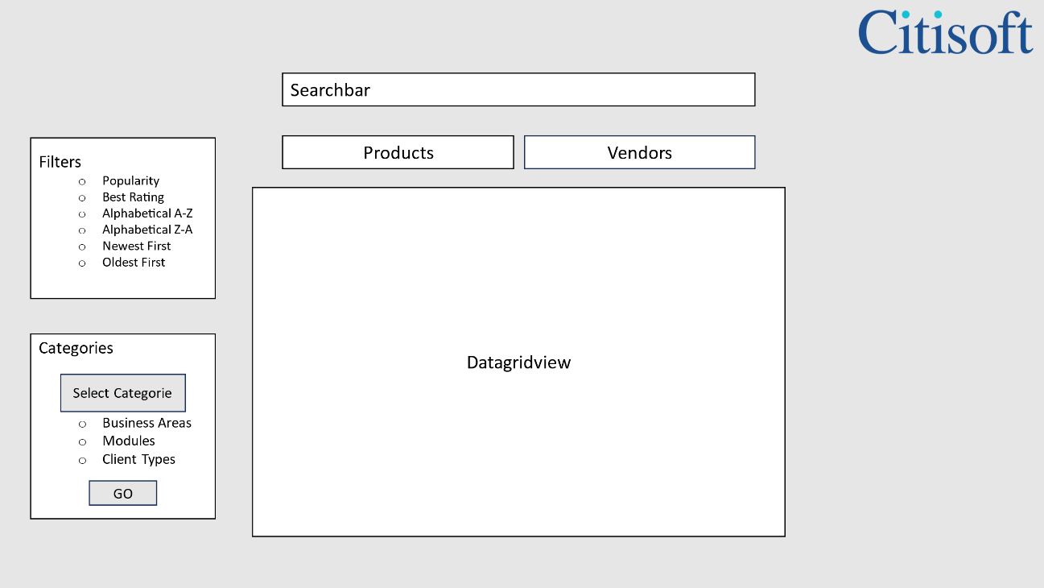
Figure 4 User Interface for user to browse through the product.
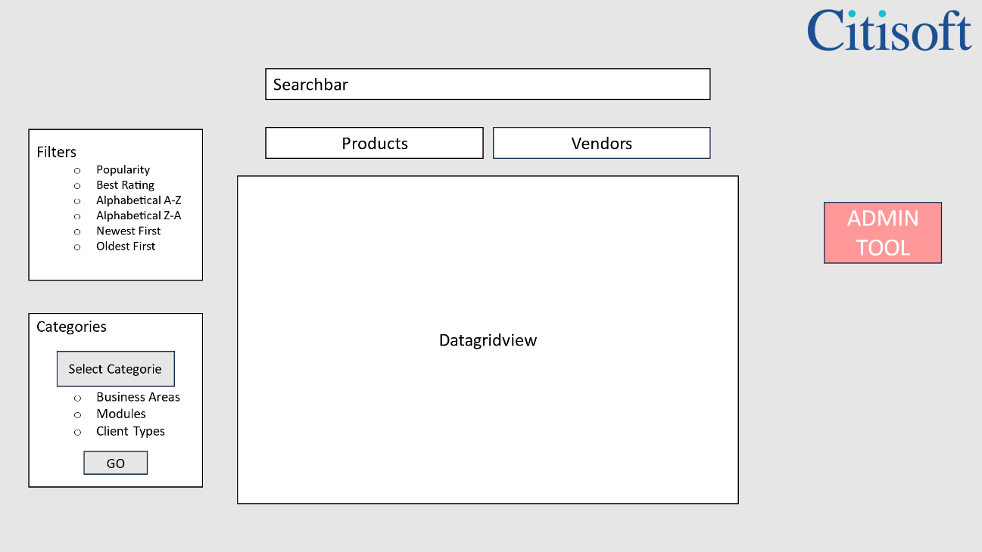
Figure 5 Admin Interface with admin tool
Description-
- Figure 4 & 5 presents the main menu page wireframe - user view and admin view with admin tool in the software.

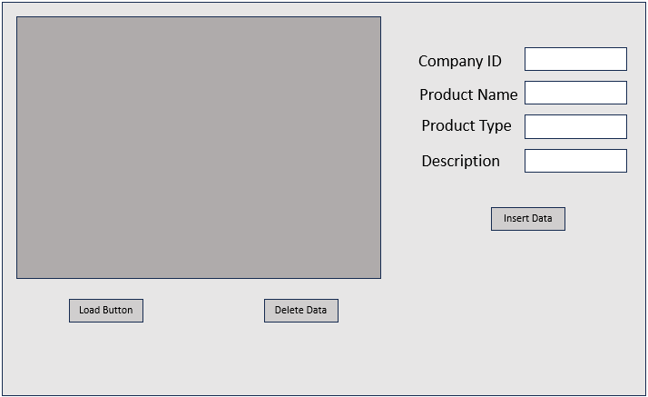
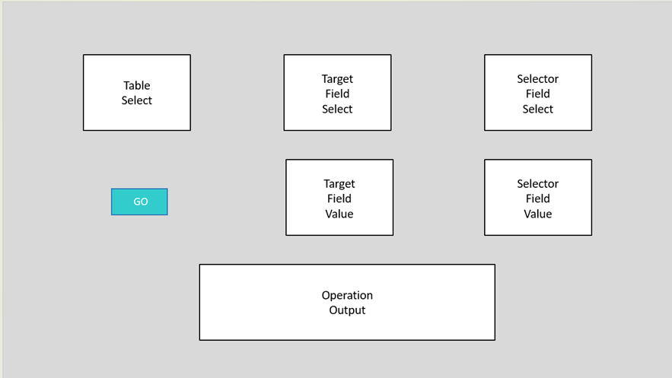
Figure 6 Edit Interface of vendor/product database.
Figure 7 Form for inserting and deleting data.
Description-
- Figure 6: present the edit interface of the vendor and product database.
- Figure 7: presents the insertion and deletion data form with Company ID, Product Name, Product Type, description.

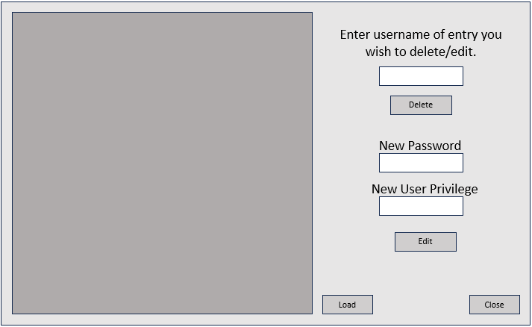
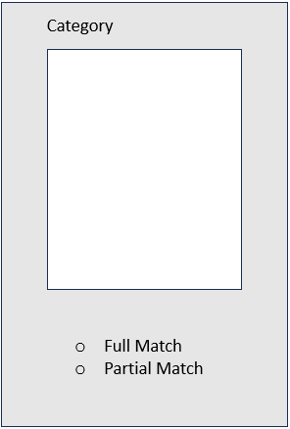
Figure 8 Form for user administration.
Figure 9 Form for category selection.
Description-
- Figure 8 presents the form for user administration within the software.
- Figure 9 presents the form for category selection of the product.

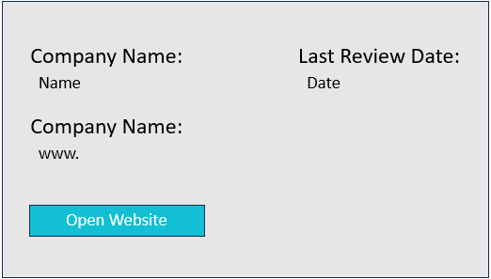
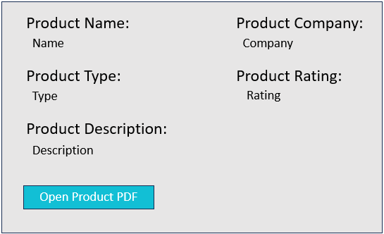
Figure 10 Form products more details.
Figure 11 Form companies more details

Description-
- Figure 10 presents the form with further details of the product which has the view product PDF functionality.
- Figure 11 presents the form with more details of the vendor which has the view vendor website functionality.

DATABASE DESIGN
    - Entity Relationship Diagram
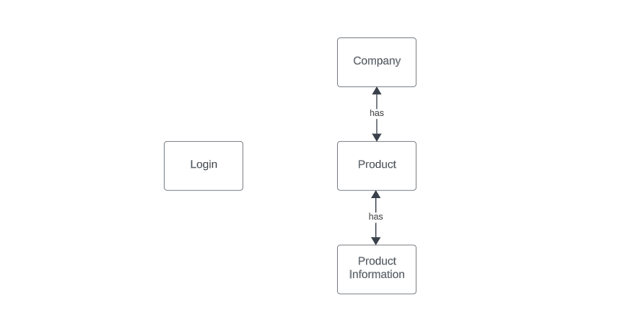
Figure 12 Entity Relation Diagram
Description-
Figure 8: This Entity-Relationship Diagram (ERD) demonstrates the relationships between users, company and the products within the database system.
Login- During the early stages of the development process the login was considered as a separate table of its own as it was not directly linked with other tables. Everyone who have a valid registered account has a login entity connected with them, differentiating access control and authentication by their access rights. Users can access their particular features and communicate with the system by providing their login credentials.
Company- The vendor/company that supplies the product is connected to this table, which serves as a repository for all vendor information. Businesses operate as systems organisational units and includes a range of products.
Product- This table keeps the record of all the products which are available. Specific characteristics about the product itself, like its name, description, price, and inventory levels, are all contained in these products.
Product information- This table’s purpose is to log all the essential information of the product. Products have attributes that fully describe them. Product names, unique IDs, descriptions, categories, prices, and any other details that identify or set the product apart might all be included in this data.
This ERD design makes data organisation easier, enabling users to be linked to certain businesses and businesses to effectively manage their own products. Users get access to information about the products connected to their affiliated vendor/company

    - Extended Entity Relationship Diagram

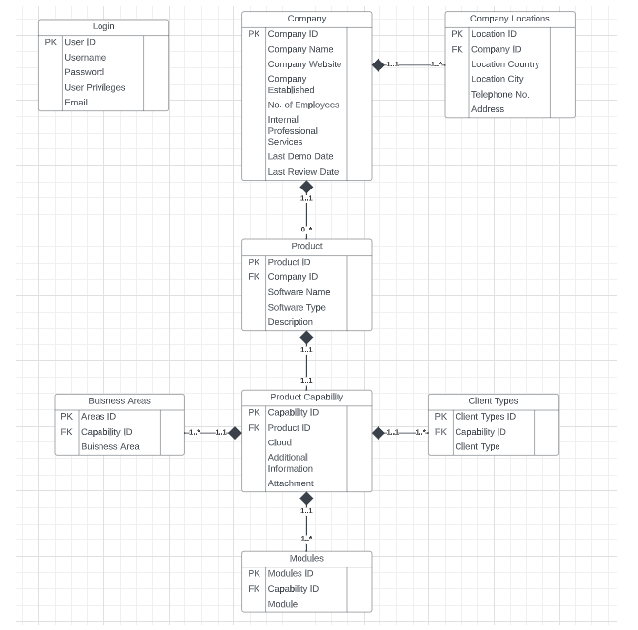
Figure 13 Extended Entity Relationship Diagram
Description-
This Extended Entity-Relationship Diagram (EERD) model lays out the structure of a comprehensive system designed to handle different aspects of the software ecosystem that an asset management company has. It defines the connections between various entities that together stand in for users, businesses, products, services, industries, clients, and modules. The EERD includes cardinalities to indicate the number of relationships that can exist between each pair of entities. For example, the cardinality of the Company-Product relationship is (1to*), which means that one company can have many products, but a product can only belong to one company.
Entities -
User: Represents individuals accessing the system. Holds data such as User ID, Username, Password, User Privileges, and Email.
Company: Represents the entities for organizations or companies. Includes attributes like Company ID, Company Name, Website, Establishment Date, Employee Count, Professional Services, Demo and Review Dates.
Company Locations: Captures the geographical details of company branches or offices. Contains data on Location ID, Country, City, Telephone Number, and Address linked to a specific Company.
Product: Represents software products offered by companies. Contains Product ID, Software Name, Type, and Description. Associated with a specific Company.
Product Capability: Defines additional features or capabilities of a product. Holds Capability ID, Cloud status, Additional Information, and Attachments. Linked to a Product.
Business Areas: Describes various business sectors or areas a product or capability serves. Contains Area ID, related to a Capability, indicating specific Business Areas.
Client Types: Represents different client classifications or types associated with a capability or product. Contains Client Type ID, associated with a Capability.
Modules: Specifies different modules or components within a capability or product. Includes Module ID, associated with a Capability, defining particular Modules.
Relationships-
User Relationships: Although not explicitly detailed, the User entity likely relates to other entities, potentially through associations like user-company interactions, product usage, or specific permissions granted.
Company Relationships: Company links to Company Locations, reflecting a company's physical presence across multiple locations.
Company associates with Product, indicating the products or software offered by a company.
Product Relationships: Product connects to Product Capability, which describes the extra features or capabilities of a certain product.
Product Capability also relates to Business Areas, customer Types, and Modules; it describes the functions of the product, the business sectors it is intended for, the customer classifications, and the component modules.

    - Table Schema

In this section, all the entities in the database are represented in tables and each data field is defined with their data type and description. As the table schema

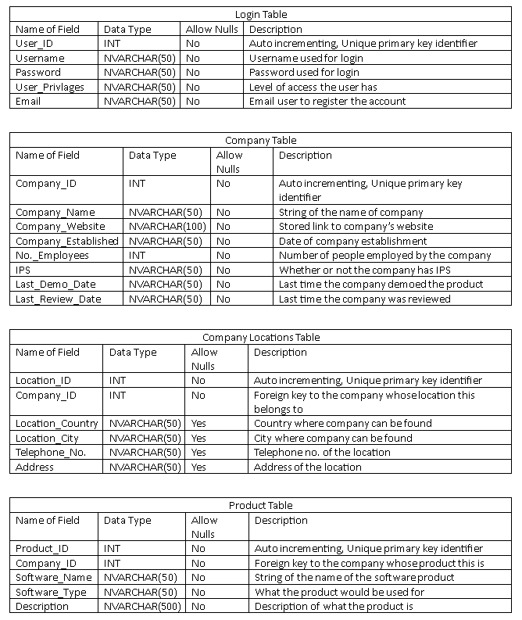
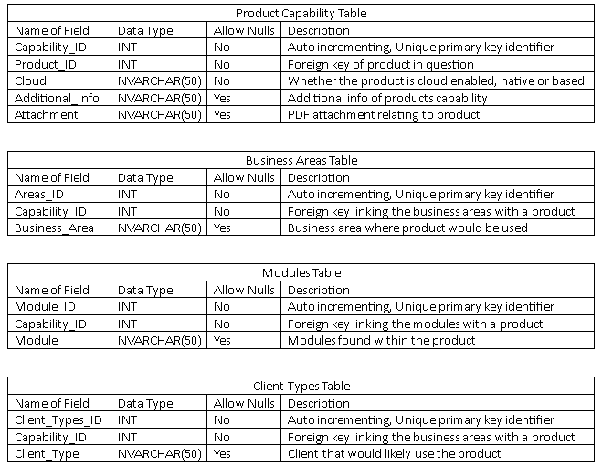

UML DESIGN DIAGRAMS

Use Case Diagram
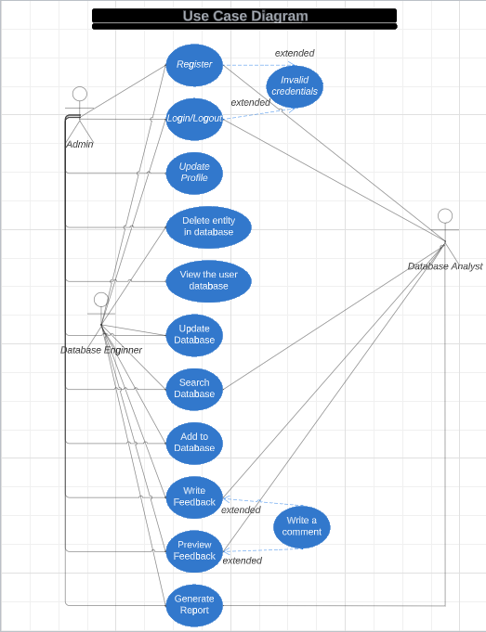
Figure 14 Use Case Diagram

Description-
Use Case Name | Registration of a new account
Actors | Admin, Database Engineer, Database Analyst
Flow of Events | - The user selects "Register" button.  - The user sees a registration form that the system displays for them to fill out.  - The individual fills out the form and presses the "Submit" button.  - The data entered by the user is verified by the system.  - The datashould be accurate, the system generates an entirely new user account within the database.  - The user's account is logged in by the system.  - The user is greeted by a message from the system.
Alternative Flows | - In the event that the user is already logged in, the system will notify them as such and direct them to the relevant page.  - The system will show an error message and provide the user with the opportunity to rectify the information if the user enters invalid data.
Entry Conditions | - The user is not logged in.  - The user does not have a valid user account in the system.
Exit Conditions | - The user has successfully registered for an account and is logged in.

Use Case Name | Login to the software
Actors | Admin, Database Engineer, Database Analyst
Flow of Events | - The user fills up the login form with their password and username.  - The user's credentials are verified by the system.  - The system logs the user into their account if the credentials are legitimate.  - The user receives a greeting from the system and is redirected to the relevant page.
Alternative Flows | - The system will notify the user that they are already logged in and direct them to the relevant page if the user is already logged in.  - The system will show an error notice and give the user the opportunity to re-enter their credentials if they are not entered correctly.
Entry Conditions | - The user has a valid user account in the system.  - The user is not logged in.
Exit Conditions | - The user is successfully logged in to their account.

Use Case Name | Logout of the system
Actors | Admin, Database Engineer, Database Analyst
Flow of Events | - The "Logout" button is clicked by the user.  - The user is logged out of the system by the system.  - The user is redirected to the login page by the system.
Alternative Flows | - If the user is not logged in, the system displays a message informing the user that they are not logged in.
Entry Conditions | - The user is logged in to the system.
Exit Conditions | - The user is logged out of the system and redirected to the login page.

Use Case Name | Update profile
Actors | Admin
Flow of Events | - The "Update Profile" link is selected by the user.  - The profile details are shown by the system.  - The profile data is updated by the system user.  - The "Submit" button is clicked by the system user.  - The new profile data is verified by the system.  - The system changes the user's profile information if the data is valid.  - A notification confirming the updating of the profile data is shown by the system.
Alternative Flows | - If the user does not enter valid profile information, the system displays an error message and allows the user to correct the information.
Entry Conditions | - The user is logged in to the system.
Exit Conditions | - The user's profile information has been updated in the system.

Use Case Name | Delete entity in database
Actors | Admin, Database Engineer
Flow of Events | - The entity that the user wishes to delete is chosen.  - The "Delete" button is clicked by the user.  - A dialogue box for confirmation is displayed by the system.  - The user attests to their desire to remove the entity.  - The entity is removed from the database by the system.  - The user receives a notification from the system verifying that the entity has been erased.
Alternative Flows | - If the user is not logged in, the system displays a login screen.  - If the user does not have the necessary permissions to delete entities in the database, the system displays an error message.  - If the entity that the user wants to delete does not exist in the database, the system displays an error message.
Entry Conditions | - The user is logged in to the system.  - The user has the necessary permissions to delete entities in the database.  - The entity that the user wants to delete exists in the database.
Exit Conditions | - The entity has been deleted from the database.

Use Case Name | View user database
Actors | Admin
Flow of Events | - The "View User Database" link is clicked by the user.  - A list of every user in the database is shown by the system.  - A user's profile details can be viewed by clicking on their name.
Alternative Flows | - If the user is not logged in, the system displays a login screen.  - If the user does not have the necessary permissions to view the user database, the system displays an error message.
Entry Conditions | - The user is logged in to the system.  - The user has the necessary permissions to view the user database.
Exit Conditions | - The actor has viewed the user database.

Use Case Name | Update database
Actors | Admin, Database Engineer
Flow of Events | - The user clicks on the "Update Database" link.  - The system displays a form for the user to enter the changes that they want to make to the database.  - The user enters the changes into the form and clicks on the "Submit" button.  - The system validates the changes.  - If the changes are valid, the system updates the database.  - The system displays a message to the user confirming that the database has been updated.
Alternative Flows | - If the user is not logged in, the system displays a login screen.  - If the user does not have the necessary permissions to update the database, the system displays an error message.  - If the changes that the user enters are invalid, the system displays an error message and allows the user to correct the changes.
Entry Conditions | - The user is logged in to the system.  - The user has the necessary permissions to update the database.
Exit Conditions | - The database has been updated.

Use Case Name | Search database
Actors | Admin, Database Engineer, Database Analyst
Flow of Events | - The user enters the search terms into the search bar.  - The user clicks on the "Search" button.  - The system searches the database for entities that match the search terms.  - The system displays a list of the search results to the user.  - The user can click on a search result to view more information about the entity.
Alternative Flows | - If the user is not logged in, the system displays a login screen.  - If the user does not enter any search terms, the system displays an error message.  - If the system does not find any entities that match the search terms, the system displays a message informing the user that no results were found.
Entry Conditions | - The user is logged in to the system.
Exit Conditions | - The user has searched the database and has been presented with the results of their search.

Use Case Name | Add to database
Actors | Admin, Database Engineer
Flow of Events | - The user clicks on the "Add to Database" link.  - The system displays a form for the user to enter the new data.  - The user enters the new data into the form and clicks on the "Submit" button.  - The system validates the new data.  - If the data is valid, the system adds it to the database.  - The system displays a message to the user confirming that the data has been added to the database.
Alternative Flows | - If the user is not logged in, the system displays a login screen.  - If the user does not have the necessary permissions to add data to the database, the system displays an error message.  - If the new data that the user enters is invalid, the system displays an error message and allows the user to correct the data.
Entry Conditions | - The user is logged in to the system.  - The user has the necessary permissions to add data to the database.
Exit Conditions | - The data has been added to the database.

Use Case Name | Write feedback
Actors | Admin, Database Engineer, Database Analyst
Flow of Events | - The user clicks on the "Write Feedback" link.  - The system displays a form for the user to enter their feedback.  - The user enters their feedback into the form and clicks on the "Submit" button.  - The system validates the feedback.  - If the feedback is valid, the system stores it in the database.  - The system displays a message to the user confirming that their feedback has been submitted.
Alternative Flows | - If the user is not logged in, the system displays a login screen.  - If the user does not enter any feedback, the system displays an error message.  - If the user enters invalid feedback, the system displays an error message and allows the user to correct the feedback.
Entry Conditions | - The user is logged in to the system.
Exit Conditions | - The user has submitted their feedback.

Use Case Name | Preview feedback
Actors | Admin, Database Engineer, Database Analyst
Flow of Events | - The user clicks on the "Preview Feedback" link.  - The system displays a list of all feedback that has been submitted.  - The user can click on a feedback entry to view the details of the feedback.
Alternative Flows | - If the user is not logged in, the system displays a login screen.  - If there is no feedback that has been submitted, the system displays a message informing the user that there is no feedback to preview.
Entry Conditions | - The user is logged in to the system.
Exit Conditions | - The user has viewed the feedback that has been submitted.

Use Case Name | Generate report
Actors | Admin, Database Engineer, Database Analyst
Flow of Events | - The "Generate Report" link is selected by the user.  - The user can choose the kind of report they wish to create by completing a form that the system presents.  - After choosing the report type to create, the user hits the "Generate" button.  - The report is produced by the system.  - The user sees the report displayed by the system.
Alternative Flows | - The system shows a login screen if the user is not logged in.  - The system shows an error notice and gives the user the option to choose a legitimate report type if they choose an invalid report type.
Entry Conditions | - The user is logged in to the system.
Exit Conditions | - The user has generated a report.

Class Diagram

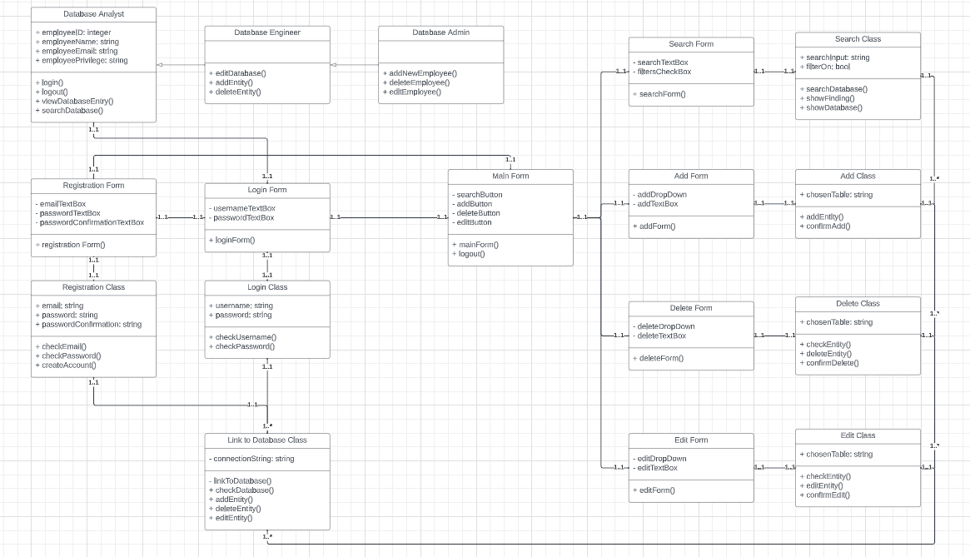
Figure 15 UML Class Diagram
Description-
The class diagram describes the types of objects/ classes in the system and its relationships between them. Database analyst is inherited from engineer and engineer from Admin as admin has the authority to access everything in the database. All the classes and forms are associated with one another with a one is to one cardinality.
Registration and Login Form are associated with Main Form. Search, Add, Delete, & Edit Form have been associated with Main Form & with Link to Database class (1to*) relationship.

Sequence Diagram
User Story 1
As a User, I should be able to register a new account in the system so that I can access into the software whenever I want.
- User can register a new account if they don’t have an account
- User have to enter their email, password and confirm password.
- The system checks if the credentials meets all the requirements.
- Saved to user database, gives registration successfully complete notification on the screen.
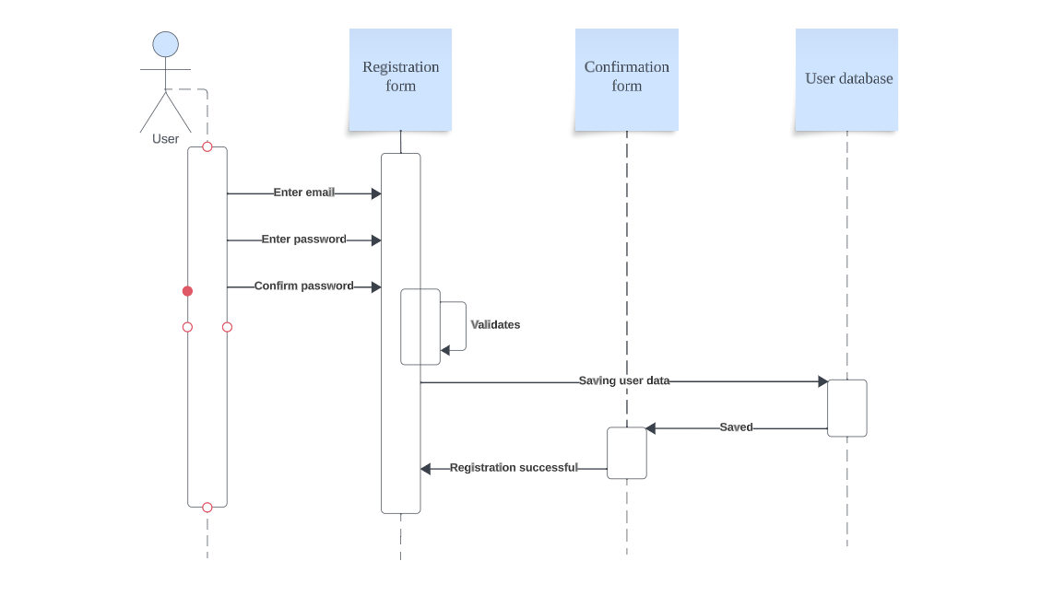
Figure 16 Registration of a new user
User Story 2
As a User/ Database Analyst, I should be able login into the account so that I can browse through the software whenever in want.
- User/ Analyst can login to their existing account using their email and password
- The login credentials gets validated if it does match it asks the user to enter the login credentials again.
- When the login credentials match user will be proceeded into the main menu.
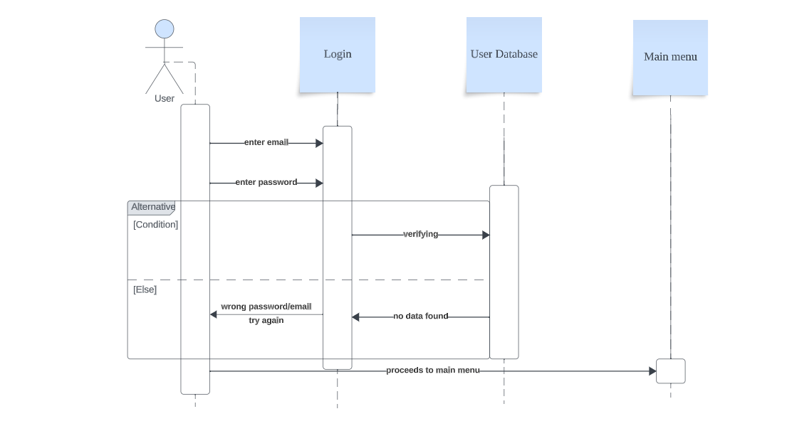
Figure 17 Log in action of an existing user
User Story 3

As a database administrator I want users to have access rights so that what a user can do with the system depends on their access rights.

- When a user tries to login to their account the admin can validate their access right
- The access level will be granted accordingly.
- Displays access granted and proceed to the main menu.
- User can perform actions in the software.
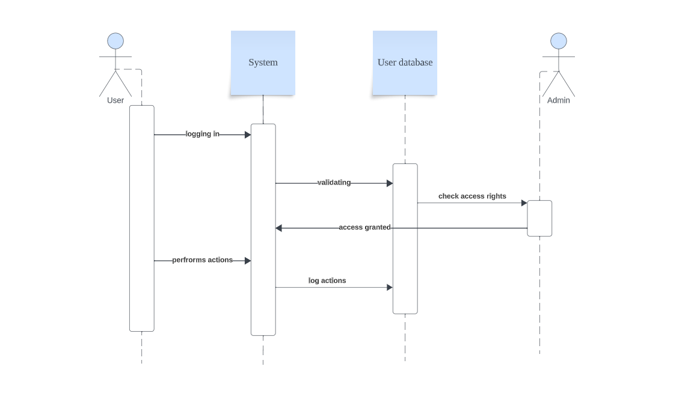
Figure 18 Validating access right for the user
User Story 4
As a database administrator, I want to be able to edit the data related to the user so that if login issues occur, I can fix them.
- Admin can edit the data of a user if there is any problem with their login.
- Admin request to edit & retrieves data from the database.
- View the data and edit then insert the edited data
- Update the database and displays confirmation of the update.
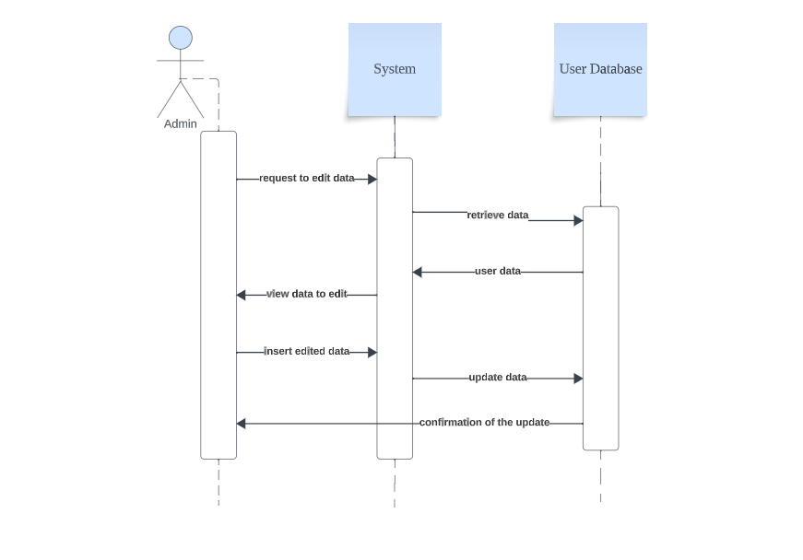
Figure 19 Edit data in the database
User Story 5
As a database analyst, I want a user-friendly main menu which GUI is not over complicated, so that I am not confused while using the application.
- Analyst/ User can access the software.
- User will have a user friendly Main menu interface.
- User can interact with the software application without getting confused.

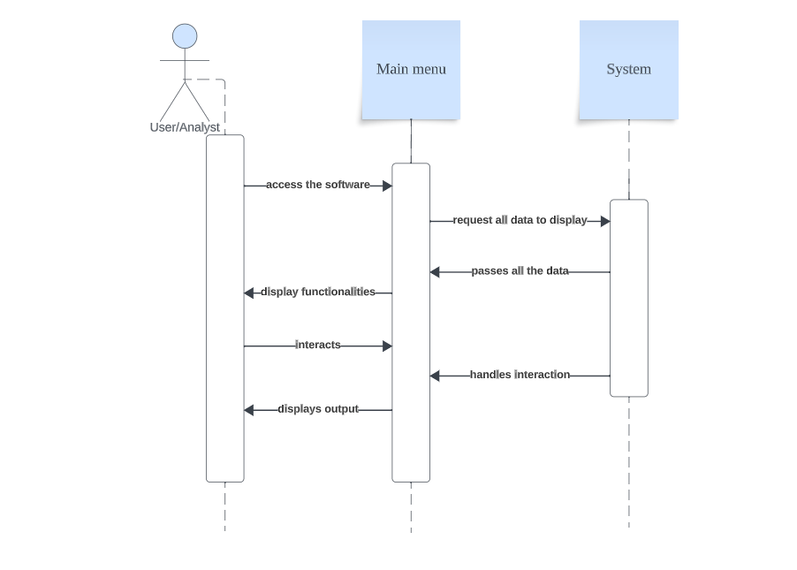
Figure 20 User-Friendly Interface which adapts according the users requirement
User Story 6
As a database analyst, I want to be able search and view the database through the software, so I can identify and select the appropriate technology for the business needs of the client.
- User can search for specific data in the search bar.
- User will get specific search result according to their search.
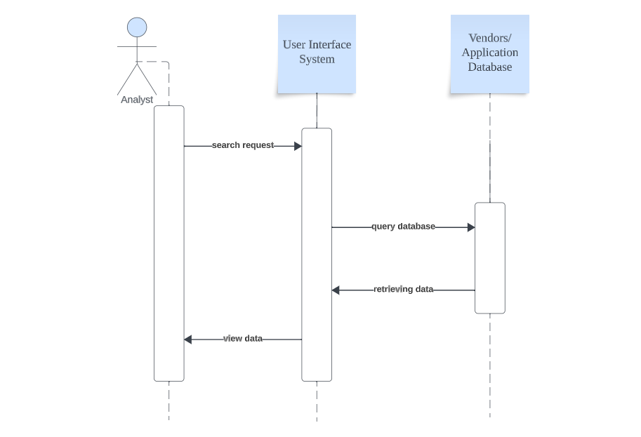
Figure 21 User using search function to meet their required result
User Story 7
As a database analyst, I want to be able to select categories and filter through the database entries to specify my search as much as possible.
- User can browse through the application and narrow down their search using filters and categories.
- User will get filtered output according to their filter down of the search.
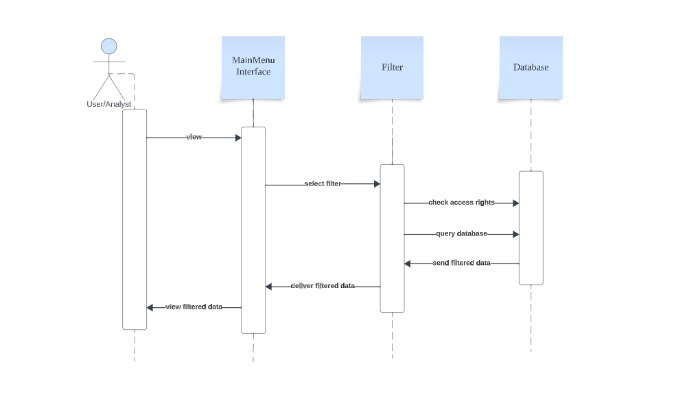
Figure 22 User using filter function to specify their search result
User Story 8
As a database analyst, I want to be able to select/open links inside the application to have faster access to vendor and product websites.
- User can view all the vendors and products available in the main menu.
- User can view further details of the product / vendor when the user press the info they would like to see.
- User can also be redirected to the vendors website from the button.
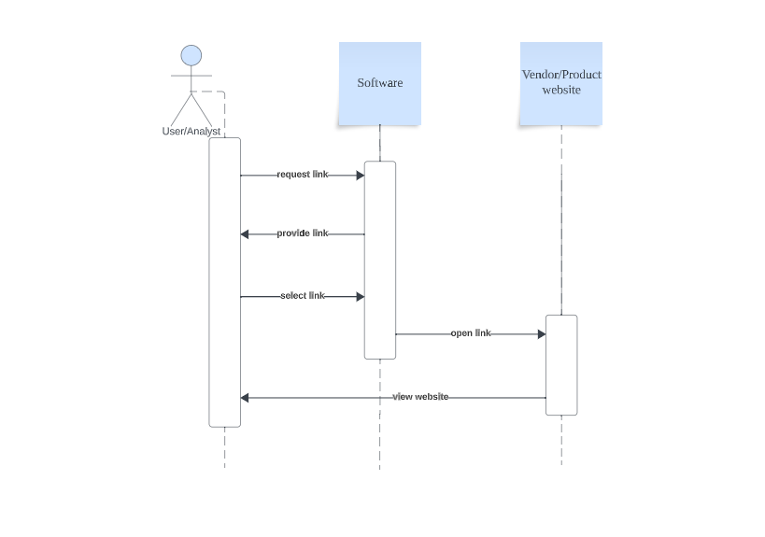
Figure 23 User opening link to the product/vendor website
User Story 9
As a database analyst, I want to be able to select/open PDF’s documents through the software, so I can view the PDF’s online.
- User can view all the details of the product within a new form.
- They can also view an online PDF from the software when they press the view PDF button.
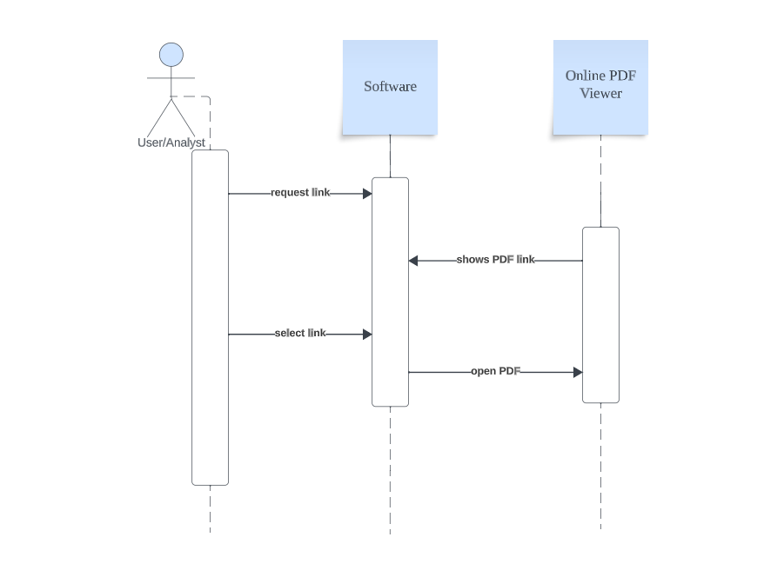
Figure 24 User selecting/opening PDF Document
User Story 10
As a database analyst I want a data repository that can store data on vendors and their products so that I have easy access to all the data in one place.
- Analyst can add data into a repository in a separate form.
- The data is stored in the repository and can be requested and retrieved whenever the user wants.
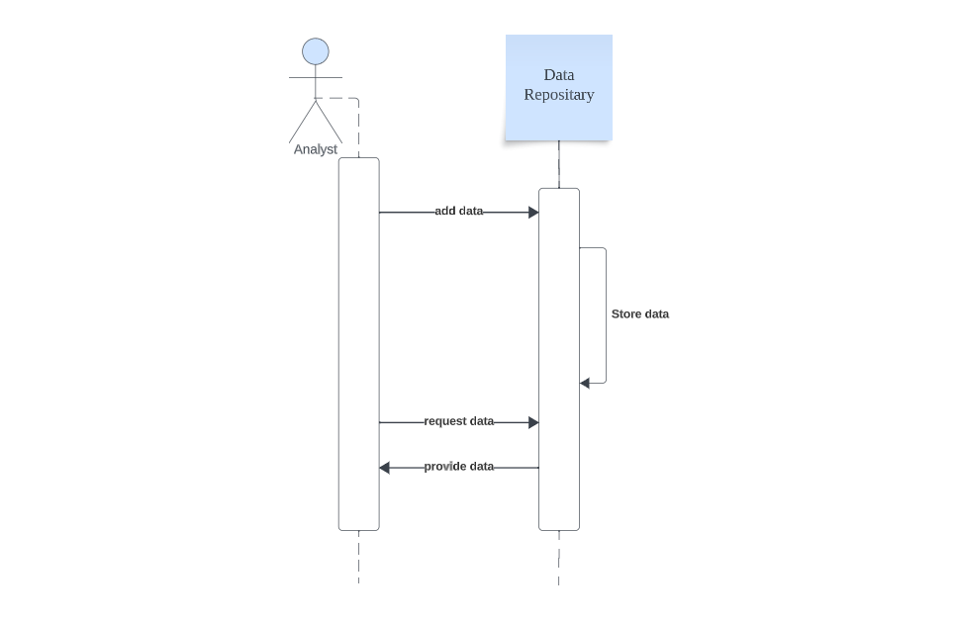
Figure 25 Database Analyst accessing and storing data in repository

User Story 11
As a database engineer, I want to be able to edit the database of the vendors and products, so that the database analyst is up to date on current/new vendors and products.
- Admin/ Engineer can select the edit button within the admin main menu.
- This opens a new form where the admin could edit the data in the database.

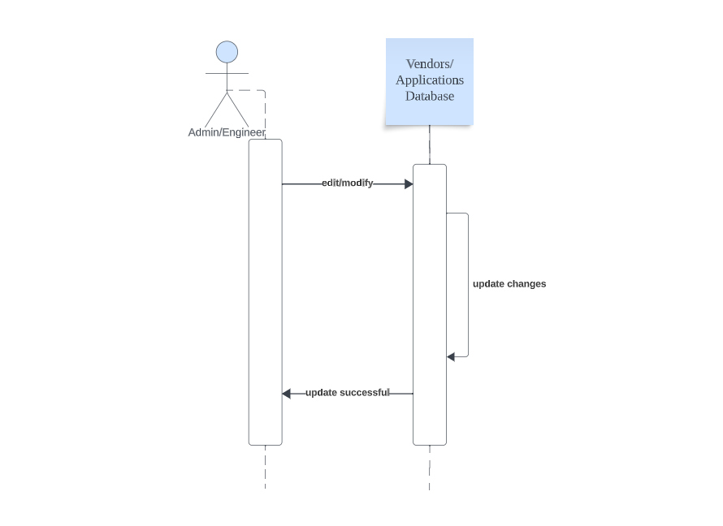
Figure 26 Database admin edit/modify the data
User Story 12
As a database engineer, I want to be able to delete product/vendor database entries so I can make sure that old entries that are not of any use anymore can be deleted and will not confuse the user.
- Admin / Engineer can select the delete button and it will show a new form where the admin could delete the data from the database.
- The updated list will be shown with an update success message.
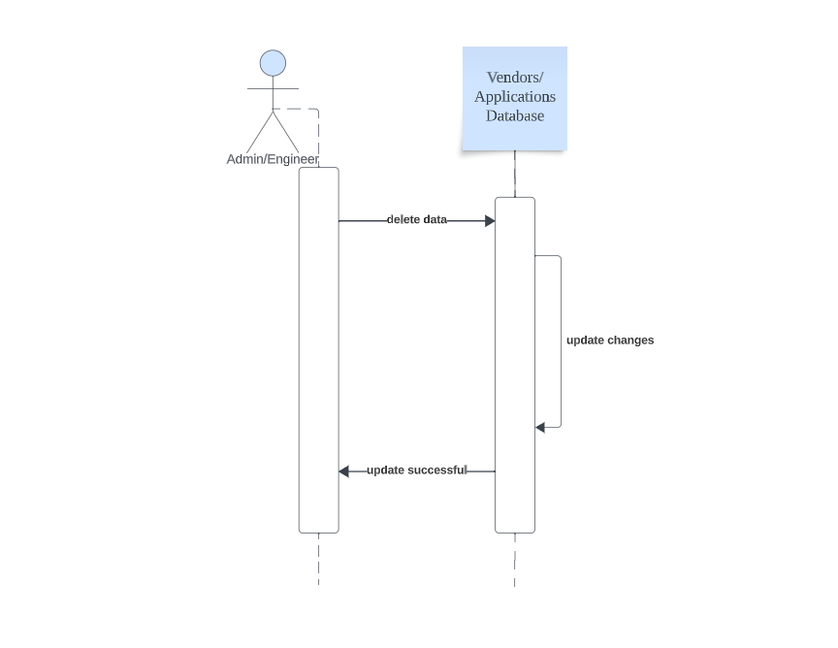
Figure 27 Database admin delete data

User Story 13
As a database engineer, I want to be able to add new data entries to the database so that the database is kept up to date on new information.
- The engineer can add new data into the database.
- The adding data has a form and it will display the updated list right away.
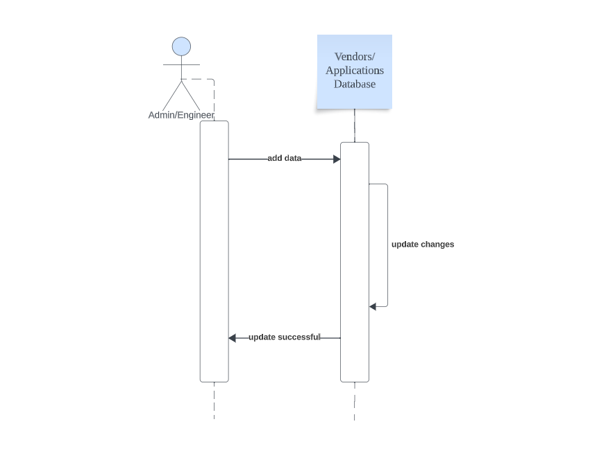
Figure 28 Database admin Add new data

User Story 14
As a database analyst, I want to be able to generate a PDF report that can be downloaded, and is displaying information of products.
- User can rate and review the products
- A generalised report of the product will be created which can be downloaded using a link.
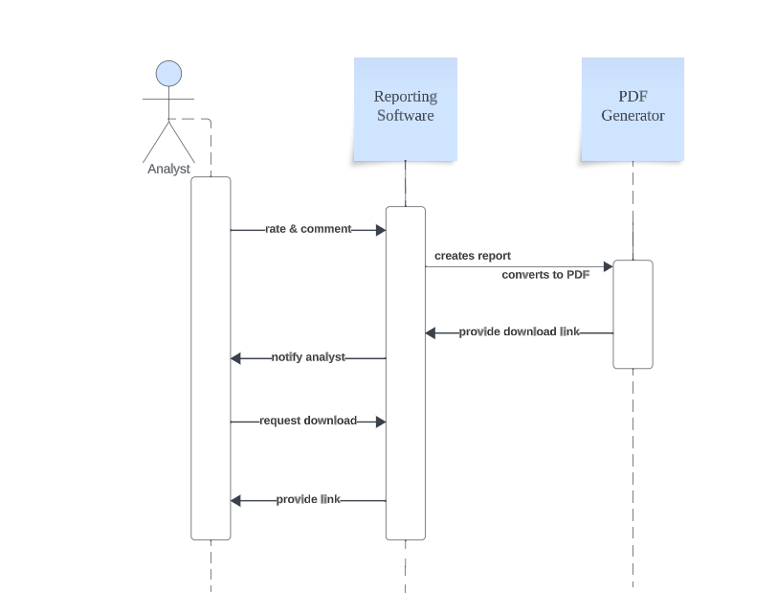
Figure 29 Database analyst can generate & download PDF report
User Story 15
As a database administrator, I want to be able to specify the date which vendors should be reviewed so that information on the vendor is kept up to date.
- Admin can specify the next review date for each vendor in the database
- The updated date will be replaced with old date.
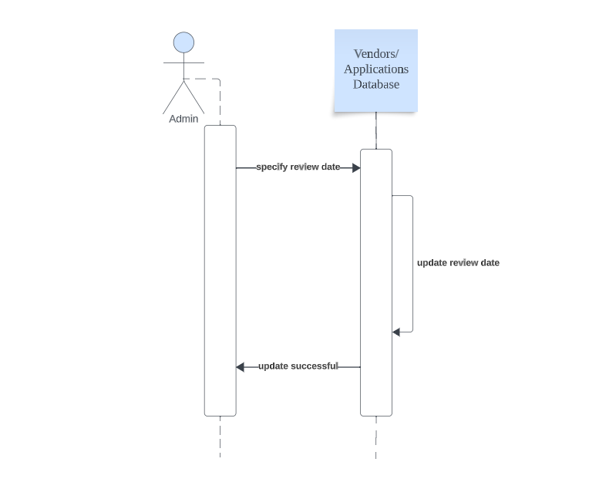
Figure 30 Database admin specifying review date
User Story 16
As a database analyst, I want to be able to rate and comment on products (and vendors) so other database analysts know which products are good quality (or which vendors are reliable).
- After the user have used the software they could rate and comment about the product.
- Rating and comments will be saved in the data base so that future users could refer and choose accordingly.
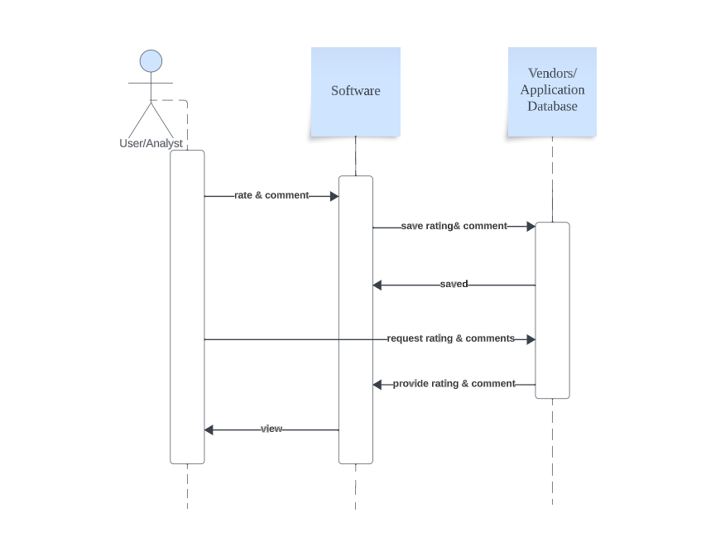
Figure 31 User can comment/rate on the products

SOFTWARE DEVELOPMENT DOCUMENTATION

USER STORY 1
“As a User/Database analyst, I want to be able to select/open links inside the application to have faster access to vendor and product websites.”
Figure 32 Sequence diagram for User story 1

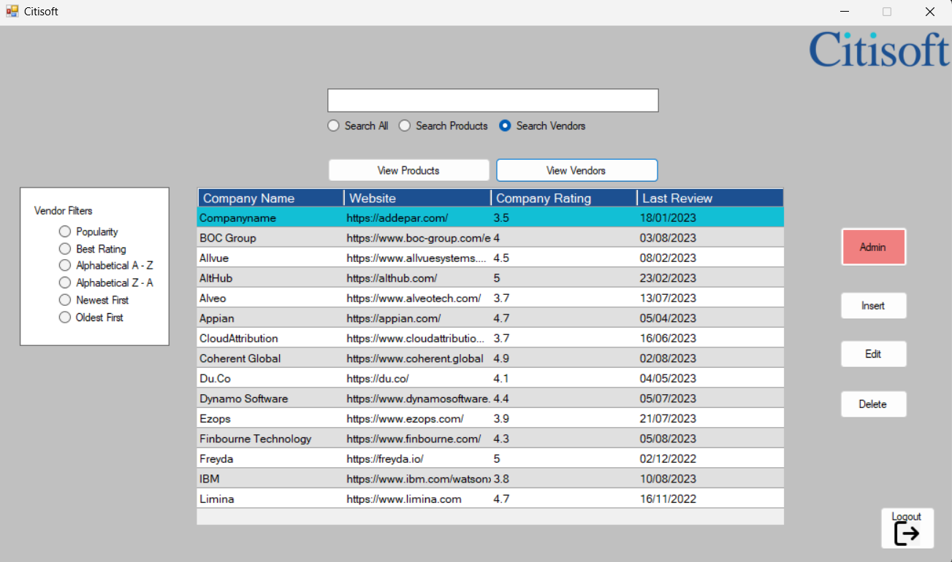
Figure 33 Main menu view with the vendors list displayed
Figure 33: This is the main menu interface with all the vendors displayed as the user chose ‘View Vendors’ button.
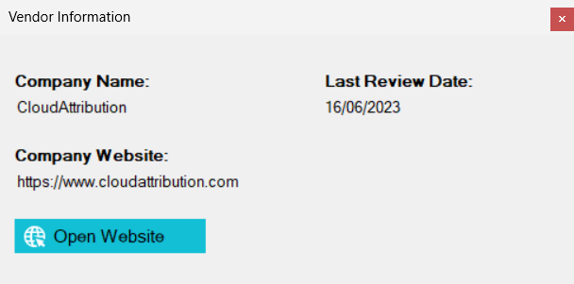
Figure 34 Form of the Vendor information view
Figure 34: This is the form which will be displayed after the user selects a particular data grid with vendor’s name from the main menu. In this form you will have the preloaded data of vendor from the database. You could press the open website button and it will redirect you into the vendor’s respective website.
Implementation-
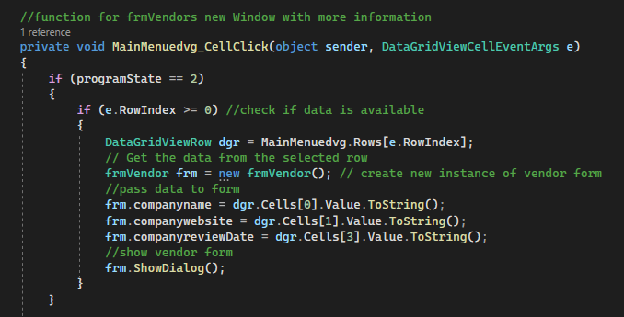
Figure 35 connection from main menu to ‘frmVendor’.
Figure 35: This part shows how the connection is established from the main menu to ‘frmVendor’ where all the data will be displayed along with button to vendor website link. At first it checks the condition that if the ‘programState’ is ‘2’, the condition check with ‘programState’ is to make sure the correct data is being called. There was only two ‘programState’ at the earlier stages as there was no ‘search all’ feature, there was only ‘search product’ & ‘search vendors’ with which uses ‘productLoaded’ and ‘vendorLoaded’ conditions respectively. Now there is three conditions 0, 1, 2 symbolizing all, product & vendor respectively. The current condition checks whether the row index selected by the user is greater than or equal to zero. Then it retrieves the data from the selected row from the ‘MainMenuedvg’. Followed by that creating a new instance and passing the data in the new form (frmVendor). As all the data were already there in the data grid view there is no need to establish a new database connection to pass the data. Values from the Data Grid View in the main menu have been assigned into each cell in ‘frmVendors’ and changed all the data into String format as there is no null value in the database. As soon as the preloading of the data is done frmVendor will be displayed with the data which were already assigned to them.
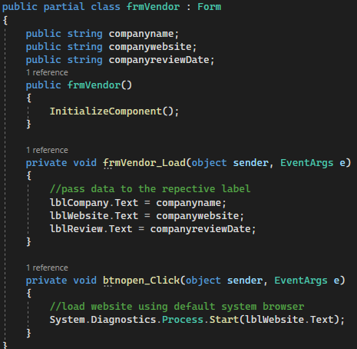
Figure 36 frmVendor code
Figure 36: frmVendor is the form created to display the details and further information of the vendor. Labels in the form are ‘lblCompany.Text’, ‘lblWebsite.Text’, ‘lblReview.Text’ have been assigned to the ‘companyname’, ‘companywebsite’, ‘companyreviewDate’ respectively, so that they will get the data accordingly. A button was assigned to load the website URL using ‘System.Diagnostics.Process.Start (lblWebsite.Text);’ this method ensures that the vendor website will open in the default web browser of the user. It uses ‘lblWebsite.Text’ string value which was assigned earlier.
Author could have used ‘IsValidUrl’ method to validate the URL string.

USER STORY 2
“As a User/Database analyst, I want to be able to select/open PDF’s documents through the software, so I can view the PDF’s online.”
Figure 37 Sequence diagram for User story 2
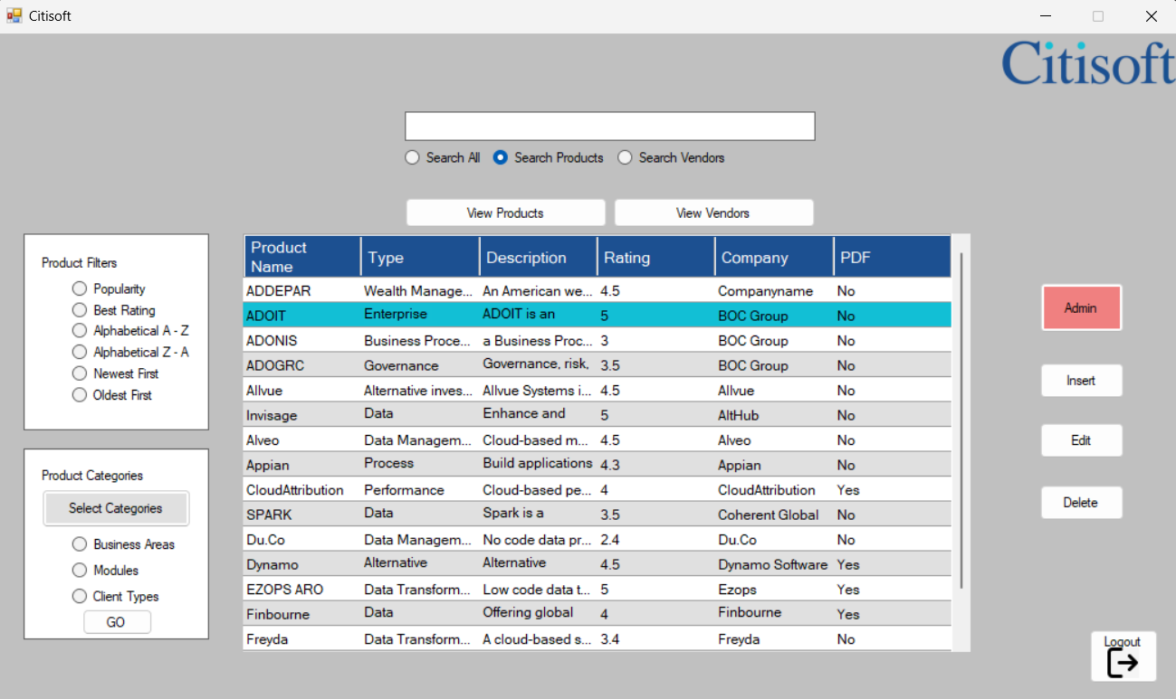
Figure 38 Main menu with products list displayed
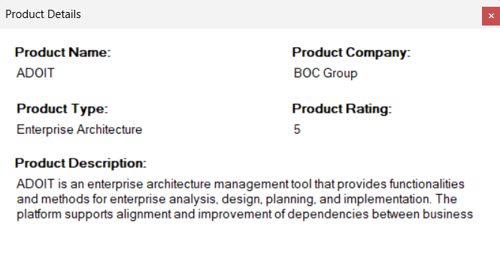
Figure 39 Form with the product information view
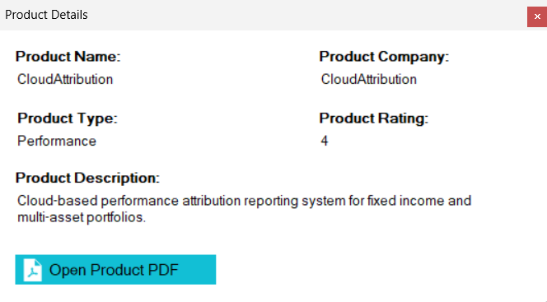
Figure 40 Form with view products information and PDF

Implementation-
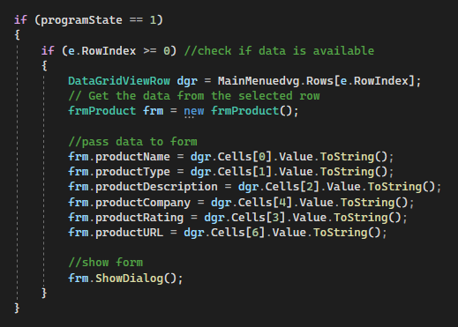
Figure 41 connection from main menu to frmProduct
Figure 41: This process is also same as the process mentioned in section 4.1. This part shows how the connection is established from the main menu to ‘frmProduct’ where all the data will be displayed along with button to open PDF of product details. At first it checks the condition that if the ‘programState’ is ‘1’, then it checks whether the row index selected by the user is greater than or equal to zero. Then it retrieves the data from the selected row from the ‘MainMenuedvg’. Followed by that creating a new instance and passing the data in the new form (frmProduct). As mentioned in the previous case all the data were already there in the data grid view there is no need to establish a new database connection to pass the data. Values from the Data Grid View in the main menu have been assigned into each cell in ‘frmProducts’ and changed all the data into String format as there is no null value in the database. As soon as the preloading of the data is done frmVendor will be displayed with the data which were already assigned to them.

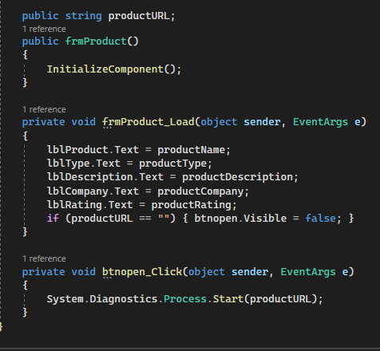
Figure 42 frmProduct code
Figure 42: frmProduct is the form created to display the details and further information of the product. Labels in the form are ‘lblProduct.Text’, ‘lblType.Text’, ‘lblDescription.Text’, ‘lblCompany.Text’, ‘lblRating.Text’ have been assigned to the ‘productName’, ‘productType’, ‘productDescription’, ‘productCompany’, ‘productRating’ respectively, so that they will get the data accordingly. All the data labels were declared in the beginning. A button was assigned to load the Product PDF URL using ‘System.Diagnostics.Process.Start (productURL);’ productURL was declared at the beginning this method ensures that the PDF file will open using the default website. Some of the Product didn’t had the feature of PDF so the data was left null in the database and a new condition was made ‘if (productURL == “ ”)’ the button will be not visible ( ‘btnopen.Visible = false’ ) so that it will only be visible when there is a product URL assigned to the product in the database.

A small change in the existing query was required to make the URL fully functional.
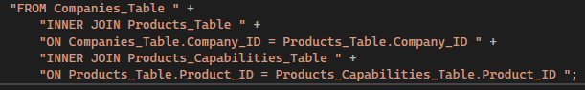
Figure 43 Screenshot of the query
The purpose of this query was to retrieve the data by joining three tables. An error occurred during the database implementation process, and the product URL ended up being an attribute in the product capabilities record rather than the product table. This led to an issue when Author tried to get the product URL data from the data grid view. By joining the table with the help of this query, the issue was resolved.
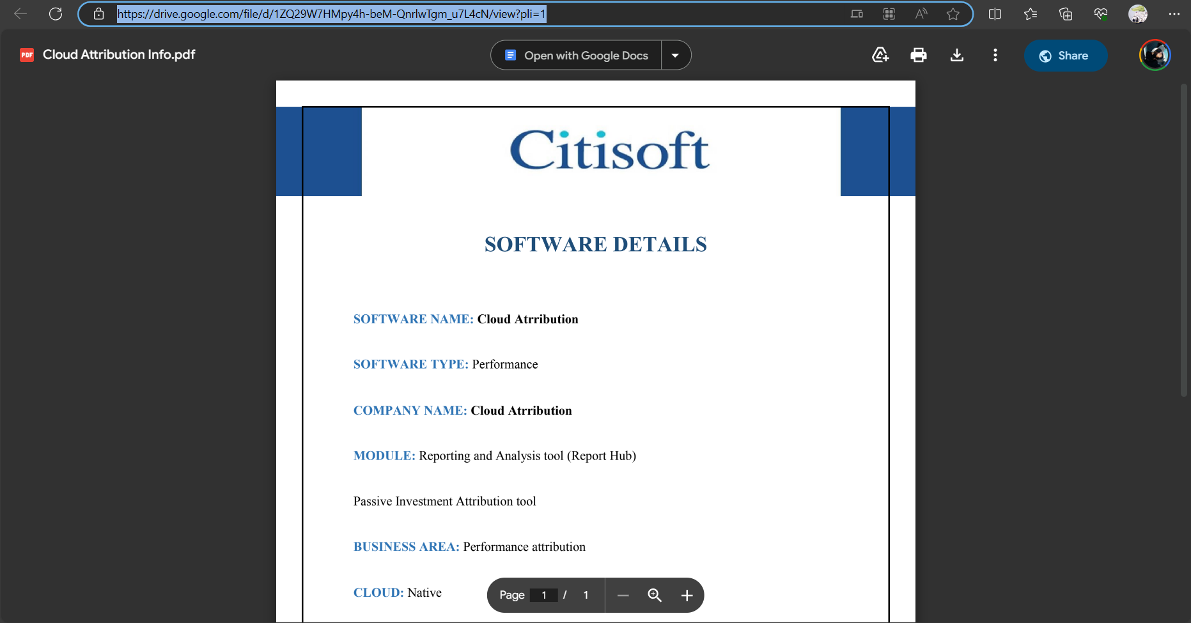
Figure 44 Screenshot of Product PDF info view
All the PDF files were created with the given details in the example vendors and products along with the case study. They have been successfully uploaded to author’s google drive as the author didn’t have access to upload the files in any custom URL.

TESTING
Test No | Test (Description) | Expected Result | Actual Result | Pass/Fail
1 | Connection to the frmProduct from the main menu | Display the data which was passed to the form. | Indexing Exception | Fail
2 | Connection to the frmProduct with proper indexing of the cells. | Display the data which was passed to the form from main menu | Displayed the product details in the assigned cells. | Pass
3 | Open product PDF link with in frmProduct. | Opens the PDF document which are saved in the drive. | Button didn’t work | Fail
4 | Open product PDF | No result. Error output expected | Button didn’t work | Fail
5 | Open Product PDF with revised connection and query. | Open PDF file | Opened the Product PDF file using the default browser | Pass
6 | Connection to frmVendor from main menu | Data to be passed to the new form | FrmVendor displayed with all the data assigned | Pass
7 | View Vendor website | Open the vendors website in the default browser | Opened the vendors website | Pass
8 | Generate Report of the product | Generate a A4 page within the software with product report and will be able to download | Generated a page but no data just a blank page. | Fail
9 | Generate Report of the product | Generate the product details in page and view in pdf viewer within the software | Error & exception | Fail
10 | Generate Report of the Product (last minute approach time limitation) | View the report file in pdf viewer | No pdf generated | Fail

Testing was done by the author many times and some of them have not been recorded as some of the testing doesn’t served any purpose. Only valid and reasonable testing for author’s part have been presented in here.

PLAN OF THE SOFTWARE MAINTENANCE
The overall software maintenance is more cost-intensive than the software production of a final product. According to a white paper published by Omnext (March 2010), software maintenance accounts for approximately 60% to 90% of the total cost of software development. This cost is due to the labour, resources, and time required to maintain and update a software system. That makes Software maintenance one of the most crucial parts of the software development lifecycle. Sommerville (2010) divides software maintenance into three parts:
Fault repairs can be simple coding mistakes, which are most likely to be resolved quickly, but also errors in the code design, which take more time to rethink and rebuild certain parts of the development software. The most expensive fault repair is a misunderstanding of the given client requirements. The unmet requirements can make a finished product worthless, set it back to the start and cost the developer significant resources. Environmental adaptation is composed of the developers adjusting the program to run on constantly changing environments, e.g., Windows and Mac OS. Functionality addition is the most significant part of the three sections, focusing on adding functions and modifications over an extensive period, as requested by the client and the developer’s suggestions.
Figure 42 Chart representation of Sommerville’s sections of software maintenance
Fault repairs
Coding errors
- Currently, saving login data for an unknown reason is impossible. Every time the program gets moved to a new location, logging in with already existing credentials is not possible.
- Another coding error involves adding and deleting data from the product and vendor database, where on one side, it is not possible to add vendors yet, but also trying to add products gives an exception and crashes the program.

Design Flaws
- Some of the data linked to products or vendors are visually inaccessible to the user, so a part of the information in the database has no current use. Therefore, the SQL statements must be adjusted to show all the data the user should have access to in the more information forms.
- Some of the filters use data that must be sourced from the users, e.g., popularity and rating because there is no current way to generate or source the required data. While the user is using the program, a counter must count the number of times a product/vendor was clicked to generate a “high score,” which would be used as a popularity measurement to show the user which program/vendor is popular. Furthermore, a rating system is needed to give the user a first impression of the quality of the product or product provider.
Environmental adaptation
- The current program using Windows Forms is not suitable for Mac OS or a Linux system. Furthermore, it is unknown if, in the future, Visual Studio 2022 will change to the degree that the program must be adjusted to that.
Functionality addition
- There is no possibility of recovering a user's password. In case of a password loss, the user must contact an administrator, who can change the password manually. Therefore, a password recovery would make a new password generation easier for the user.
- To keep the user up to date, a Changelog would be necessary. Every time something changes in the data repository, the user would be messaged about the change in a notification popup to ensure that the most recent information is being shown.
- Beneficial for the already mentioned rating system would be a comment function where users can state important information they want to share about the vendors or products, for example, good or bad experiences they want to mention specifically.
- To make the handling and maintaining of the database more effortless, the products and vendors should have review dates to ensure that the integrity of the database is maintained and the customer has the best support possible while searching for the right product without experiencing disappointments through incurrent data.
- In addition to the already attached PDFs of the products, creating a printable report about specific vendors and products would also be helpful to give customers an overview of the information of a selected product immediately without re-accessing the database.

CONCLUSION
My experience learning software development was exciting. I was a little confused when I first started working on Windows Forms and GitHub projects. But being a member of an incredible team was crucial.
We explored the Software Development Lifecycle and Agile approach in addition to coding. Seeing how important task management, teamwork, and communication are in this area was surprising. All though we had to face so many difficulties through-out the completion of this project we managed complete it successfully. Adding more features and functionalities is always an option and will not be limited. I believe no software is a perfect software there is always room for improvement.
Because of our commitment, this project became enjoyable, and this project paved the way for many more exciting future collaborations.
I am excited about the countless opportunities that lie ahead in my career as a software developer, which is just getting started. With my newfound expertise and passion for this area, I'm eager to see where our upcoming projects will take us.

REFERENCES
- Berndtsson, M., Hansson, J., Olsson, B. and Lundell, B., 2006. Planning and Implementing your Final year project – with Success!: A Guide for Students in Computer Science and Information Systems. Springer.
- Cockburn (2001) Agile Software Development: The People Factor, (Accessed 08 December 2023)-https://www.researchgate.net/publication/2955526_Agile_software_development_The_people_factor
- Bock, P., 2001. Getting It Right. R&D Methods for Science and Engineering. Academic Press.
- Burke, R., 2004. Project Management – Planning and Control Techniques. Wiley.
- Elmasri, R. and S. B. Navathe (2015). Database Systems Fundamentals, Seventh Edition. Pearson.
- Morris, S., Rob, P., and Coronel, C. (2016). Database Systems: Architecture, Execution, and Administration (12th ed.). Cengage Education.
- Wallstreet and Techguide (nd) Strategic Technology and Operations Assessment, Available at: https://www.wallstreetandtechguide.com/company/221398/products/206291/strategic-technology-and-operations-assessment (Accessed 08 December 2023)
- Citisoft (September 2023) Software Engineering Live Brief, Available at: https://canvas.anglia.ac.uk/courses/33889/files/4264708?module_item_id=1976124 (Accessed 08 December 2023)
- Mac Rehkopf (nd) User stories with examples and a template, Available at: https://www.atlassian.com/agile/project-management/user-stories (Accessed 10 December 2023)
- Nick Babich (2021) Wireframing: 8 Pro Tips for Designers, Available at: https://uxplanet.org/wireframing-8-pro-tips-for-designers-ec3e5a968f6b (Accessed 10 December 2023)
- John Mylopoulo (2004) IV. The (Extended) Entity-Relationship Model, Available at: http://www.cs.toronto.edu/~jm/2507S/Notes04/EER.pdf (Accessed 10 December 2023)
- Visual paradigm (nd) What is Use Case Diagram? https://www.visual-paradigm.com/guide/uml-unified-modeling-language/what-is-use-case-diagram/ (Accessed 10 December 2023)
- Visual paradigm (nd) What is Class Diagram? https://www.visual-paradigm.com/guide/uml-unified-modeling-language/what-is-class-diagram/#:~:text=In%20software%20engineering%2C%20a%20class,and%20the%20relationships%20among%20objects. (Accessed 10 December 2023)
- Lucid Content Team (nd) UML Sequence Diagrams Made Easy https://www.lucidchart.com/blog/lucidchart-uml-sequence-diagram-markup (Accessed 10 December 2023)
- Akshay Pai (2023) Manual Testing vs Automation Testing, Available at: https://www.browserstack.com/guide/manual-vs-automated-testing-differences (Accessed 10 December 2023)
- DataGridView's MSDN documentation is available at https://docs.microsoft.com/en-us/dotnet/api/system.windows.forms.datagridview
- C# Tutorials and Documentation on DataGridView: https://www.c-sharpcorner.com/technologies/datagridview
- Microsoft C# Programming Guide: https://docs.microsoft.com/en-us/dotnet/csharp/programming-guide/

